Greene County Cycling Team
Important Dates
August 12, 2017 First Team Meeting
August 20, 2017 First Team Practice
September 23, 2017 Race #2 Gallatin, TN (Nashville area)
October 8, 2017 Race #3 Knoxville, TN
October 29, 2017 Race #4 Sewanee, TN (Chattanooga area)
November 12, 2017 End of Season Bash
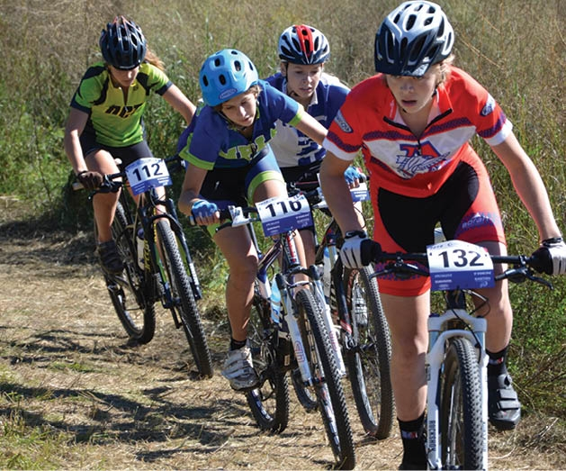

This is the first year for the Greene County Cycling Team. Cycling provides people with a fun, healthy sport that can enrich their lives even into adult. Like most other sports there are also scholarship opportunities at some schools for mountain and road cycling. And as with any sport, joining the team is a serious commitment. It requires self-discipline and a strong work ethic. Members must commit to three practices a week from August through the first week of November, four races in fall, and all team meetings.
Why commit? The GCCT has much to offer: as a team we will learn skills quickly, receive valuable coaching, and drive each other to achieve. We set goals and work collaboratively to not only attain these goals, but to also develop a wide range of valuable skills. When you ride with a team, its makes training seem like fun instead of hard work, the improvement comes quickly and steadily and soon after that – your racing results vastly improve. Since its first year, BHS Team members have had many impressive race victories as well as many extremely enjoyable riding experiences. But what's more important is that this team is about setting high goals, improving your skills, and achieving your personal best.
The GCCT is a cross-country mountain bike team, a specific form of cycling which is set apart from road riding, downhill racing, dual slalom, trials, BMX, cyclo-cross, and track racing. Cross-country mountain biking includes the broadest range of skills and team members often bring with them backgrounds and skills gained from the other sports. For the greater good of the team and high school racing, this team’s activities are focused upon preparing for and racing at cross-country mountain biking events only. The coaching staff’s highest goal is to provide students that have the desire to mountain bike the direction and camaraderie that will help them achieve both competitive success and personal development in a safe and enjoyable manner. The coaching staff and I welcome you to a new team, please read through all of the requirements and important dates. If you are not sure about the commitments or any of the requirements, please contact me directly so we can talk about your situation. Also, if you are in need of equipment or a bike, please let us know as soon as possible. We are looking forward to the rides and to getting to know the new team members. Happy Trails, Mr. Noah Naseri, Head Coach

ALL TEAM MEMBERS ARE REQUIRED TO:
• Get a physical (make your appointment immediately)
• Fill out the Sign-Up Form
• Get the release forms filled out and signed by your parents
• Get your bike and equipment checked off by one of the coaches
• Attend the team rules meeting and the team safety meeting
REQUIRED EQUIPMENT:
• Snell approved helmet (most helmets are snell approved)
• Flashing red light for use on bike
• Mountain bike (only front suspension is recommended)
• Click in pedals are recommended for both safety and efficiency
• Gloves and eye protection (recommend generic sport glasses under $10)
• Cycling shorts (lycra or baggy)
• One team uniform (jersey and shorts)
• Wind breaker, leg warmers, and arm warmers
FALL TEAM MEETINGS:
• Meetings will be held at Chuckey-Doak High School
TENTATIVE PRACTICE SCHEDULE:
• Tuesday, Wednesday: 4:15 PM or earlier if possible at Chuckey-Doak or other venues
• Sunday: 1:00 PM at various locations
DUES:
• We have scholarships available for those who cannot afford the dues

